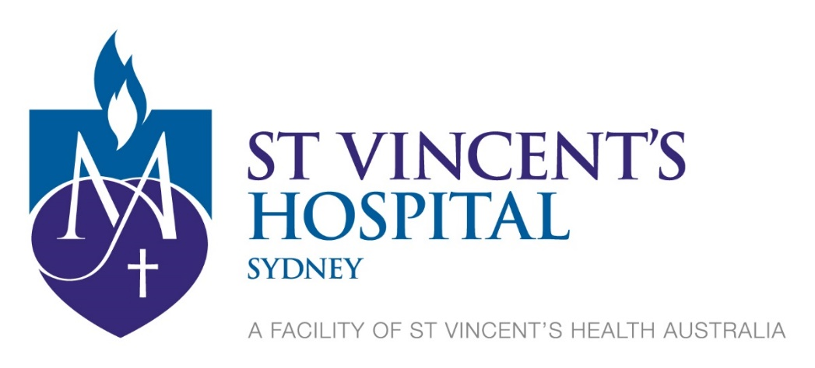
St Vincent’s Hospital (Sydney)
Human Research Ethics Committee (HREC)
Membership Constitution

All meetings are held at St Vincent’s Hospital at 5pm on the dates outlined on the ‘Meeting Dates and Submission Deadlines” page on the Research Office website.

This HREC is constituted and operates in accordance with the National Health and Medical Research Council’s National Statement on Ethical Conduct in Human Research (2007, updated 2018, 2023 and 2025) and the CPMP/ICH Note for Guidance on Good Clinical Practice.

The Committee comprises of the following:
- At least 8 members
- Chair x 1
- Deputy Chair x 1
- Equal numbers of men and women
- One third of the members are from outside St Vincent’s Hospital
- At least 2 lay people (one man and one woman)
- At least one member with knowledge of and current experience in the professional care, counselling or treatment of people
- At least one minister of religion
- At least one lawyer – not engaged to advise the institution
- At least two people with current research experience that is relevant to research proposals to be considered at the meetings
- At least one member with experience in reflecting on and analysing ethical decision-making

A/Prof Jane Carland / Chair / Research | Dr Liam Acheson / Deputy Chair / Research
Dr Keith Fay / Professional Care | Mr Steven Faddy / Research
Dr Meg Barnet / Professional Care | Dr Luis Winoto / Professional Care
Mr David Stefanoff / Community Member | Ms Melinda Jolly / Pastoral Care
Mrs Katy Haddock / Community Member | Dr Renee Johnson / Research
Ms Betsy Howard / Community Member | Mr Christopher Rofe / Research
Ms Dianne Truss / Community Member | Dr Carl Moller / Research
Dr Evan Cunningham / Research | Dr Ning Song / Professional Care
Ms Alexandra Adams / Lawyer | Dr Yiling Situ / Professional Care
Dr Jack Collins / Research | Ms Kate Merlin / Research
Ms Estelle Pearson / Community Member | Mr James Green / Research
Dr Joanne Carson / Research

